# FocusFirst- An Antiprocrastination Web Tool

**1. Introduction**

Procrastination is a pervasive challenge affecting productivity across various domains, from academic pursuits to professional tasks. FocusFirst is an innovative antiprocrastination tool designed to tackle this issue by providing users with structured strategies and motivational support. This report outlines FocusFirst objectives, features, and functionality, offering a comprehensive overview of how it addresses procrastination and enhances productivity.

**2. Objectives**

FocusFirst aims to address procrastination by offering a systematic approach to time management and task organization. The primary objectives of FocusFirst are:

* **Increase Productivity:** Facilitate efficient task completion by implementing time management techniques and reducing procrastination.
* **Enhance Focus:** Minimize distractions and create a conducive work environment through advanced features.
* **Motivate Users:** Provide continuous motivation and goal-setting tools to sustain user engagement and commitment.
* **Improve Time Management:** Offer structured methods for managing time effectively, ensuring tasks are completed in a timely manner.

4

**3.2 Pomodoro Timer**

The Pomodoro timer is a central feature of FocusFirst, implementing the Pomodoro Technique to enhance productivity. Key aspects include:

* **Work Intervals:** Users work in focused intervals (typically 25 minutes) followed by short breaks (5 minutes).
* **Extended Breaks:** After a set number of intervals, users take a longer break (15-30 minutes) to recharge.
* **Customizable Settings:** Users can adjust interval lengths and break times according to their preferences.

**3.3 Distraction Blocker**

To prevent distractions, FocusFirst includes a distraction blocker that limits access to non-essential websites and applications. Features include:

* **Customizable Block Lists:** Users can create lists of sites and apps to block during work periods.
* **Temporary Access:** Allows temporary access for essential tasks or breaks.

**3.4 Goal Setting & Tracking**

FocusFirst supports goal setting and progress tracking to help users stay motivated. Key features are:

* **SMART Goals:** Users can set Specific, Measurable, Achievable, Relevant, and Time-bound goals.
* **Progress Monitoring:** Tracks progress toward goals and provides visual indicators of achievemets.
* **Milestone Alerts:** Sends notifications when users reach significant milestones.

**4. Functionality**

FocusFirst integrates its features into a cohesive user experience, designed to streamline task management and productivity. The application operates through a user-friendly interface that allows easy access to its various tools. Functionality details include:

* **User Interface:** A clean and intuitive design that enables users to navigate between features seamlessly.
* **Integration with Calendars:** Syncs with external calendars to import deadlines and schedule tasks.
* **Data Synchronization:** Ensures that progress and settings are updated across all devices.

**5. Technologies Used:**

* + **HTML:** Provides the structure and content of the web app, including the task list, timers, and progress tracker.
* **CSS:** Used for styling the app, ensuring a responsive and visually appealing design across various devices. CSS animations may be used to create engaging visual effects.
* **JavaScript:** Powers the interactive features of the app, such as adding and managing tasks, operating the Pomodoro timer, and updating the progress tracker.

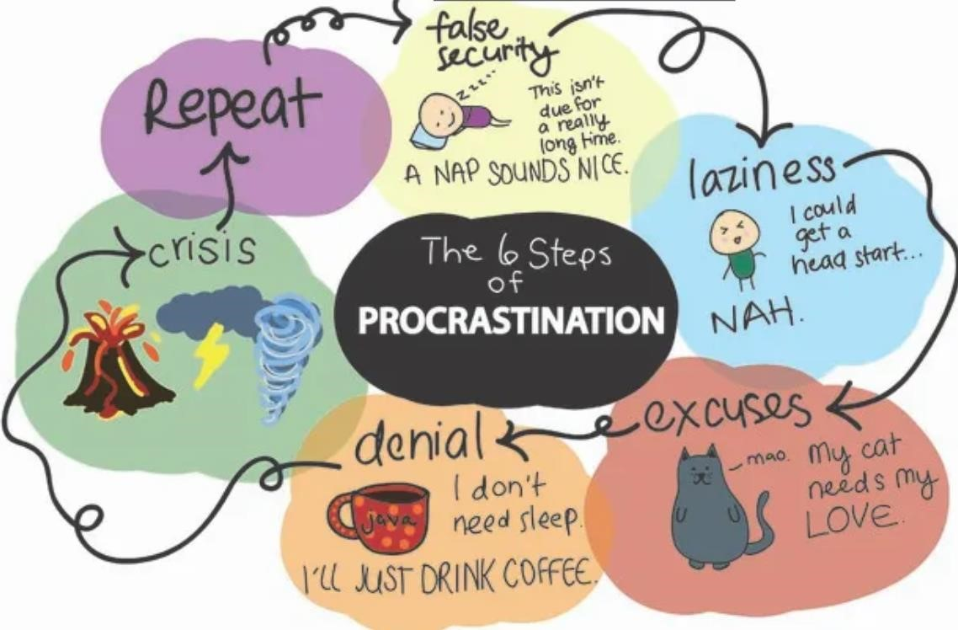

**6. Benefits**

**6.1 Enhanced Productivity**

By organizing tasks and minimizing distractions, FocusFirst helps users complete work more efficiently. The Pomodoro Technique encourages sustained focus and reduces the tendency to procrastinate.

**6.2 Improved Focus**

The distraction blocker and structured work intervals create an environment conducive to focused work, reducing interruptions and enhancing concentration.

**6.3 Increased Motivation**

Goal-setting tools and personalized reminders keep users engaged and motivated. Tracking progress and achieving milestones provide a sense of accomplishment and drive continued effort.

**6.4 Better Time Management**

FocusFirst helps users manage their time effectively by breaking tasks into manageable intervals and prioritizing them based on importance. This structured approach ensures timely completion of tasks.

**6.5 Customization**

The tool’s customizable features, such as adjustable Pomodoro intervals and block lists, allow users to tailor the experience to their specific needs and preferences.

**7. Target Audience**

FocusFirst is designed for a broad range of users who face challenges with procrastination and time management. The primary target audience includes:

* **Professionals:** Individuals in the workforce who need to manage multiple tasks and deadlines efficiently.
* **Students:** Learners who require structured study sessions and goal-setting tools to enhance academic performance.
* **Freelancers:** Self-employed individuals who must balance various projects and client demands.
* **Anyone Seeking Productivity Improvement:** Individuals looking for effective strategies to overcome procrastination and boost productivity.

**8. Conclusion**

FocusFirst offers a comprehensive solution to procrastination, combining time management techniques, distraction prevention, and motivational tools into a unified platform. By addressing both the psychological and environmental factors that contribute to procrastination, it empowers users to improve their productivity, achieve their goals, and manage their time effectively. With its user-friendly design and customizable features, FocusFirst is well-positioned to support a diverse range of users in overcoming procrastination and enhancing their overall productivity.

This synopsis report provides a thorough overview of FocusFirst, detailing its objectives, features, functionality, benefits, and target audience, and highlights its role in transforming productivity and task management.

**9. References**

**Academic Papers**

1. **"Procrastination: A Scientific Guide on How to Stop Procrastinating"**
   * Author: Tim Pychyl
   * Published in: Journal of Behavioral Medicine, 2020
   * Overview: This paper reviews scientific research on procrastination and provides evidence-based strategies to overcome it.
2. **"The Relationship Between Procrastination, Impulsivity, and Motivation in College Students"**
   * Authors: P. Steel & J. Ferrari
   * Published in: Educational Psychology Review, 2005
   * Overview: Examines how procrastination is related to impulsivity and motivation among college students.

**Websites**

1. **The Pomodoro Technique**
   * Overview: Official site for the Pomodoro Technique, a popular time management method that uses intervals of focused work followed by short breaks.
2. **MindTools: Time Management**
   * Overview: Provides various resources, articles, and tools for effective time management and overcoming procrastination.
3. **Behavioral Science in the Wild: Overcoming Procrastination**
   * Overview: Explores behavioral science approaches to overcoming procrastination and improving productivity.

**Online Articles and Blogs**

1. **"How to Stop Procrastinating: 8 Ways to Stop Procrastinating"**
   * Author: Elizabeth Scott, Ph.D.
   * Published on: Verywell Mind
   * Link: Link to Article
   * Overview: Offers practical advice and techniques for overcoming procrastination.
2. **"The Ultimate Guide to Beating Procrastination"**
   * Author: James Clear
   * Published on: James Clear Blog
   * Link: Link to Article
   * Overview: Discusses methods for tackling procrastination and boosting productivity.
3. **"Why You Procrastinate (It Has Nothing to Do With Self-Control)"**
   * Author: Tim Urban
   * Published on: TED Blog
   * Link: Link to Article
   * Overview: A popular TED Talk that provides a humorous and insightful look into procrastination and its underlying causes.